# Lab 7 – Lists: Larger Than N

From textbook

You will create your program in the IDLE environment and save it as a python file. Use the file naming convention *yourlastname*_Lab7.py.

**Modularity** – Your program should have at least these two functions:

main – should accept input of a series of 10 integers from the user and an integer n that will be the search number. main should call the function display_larger and pass 2 arguments: the 10 integers stored in a list, and the number n.

display_larger – should accept the 2 parameters from main. Using a loop, the function should compare all numbers in the list of number from the user to n. If the number is larger than n, it should be stored in a second list containing only the numbers that are greater than n.

This function should display: The original list, n, and the list of numbers greater than n.

**Sample Dialog/Output:**

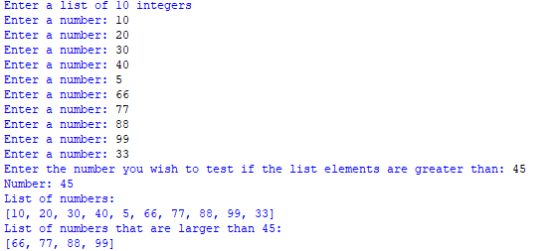

**Programming Style Requirements.**

* Comments – Begin your program with a comment that includes: a) your name, b)program status – either “Complete” or describe any incomplete or non-functioning part of your program c)A 1-3 line description of what the program does.
* Function comments – each function should begin with a comment explaining what the function does
* Variable names – use meaningful variable names such as total_taxes or num_cookies.
* Function names – use meaningful verb names for functions such as display_taxes.
* Named constants – Use named constants for all number values that will not be changed in the program such as RECIPE_SUGAR = 1.5. See section 2.9 on Named Constants